Take Home Exam #2: **Node.js Events: File Watcher App**

Create a Node.js console app that will watch or listen to any file changes within a specified directory. The app will try to read the file and if it contains your name, it will show a Toast message informing the user that a file within a path being watched, contains the user’s name. It will also print out a console message displaying same details.

Sample toast message:

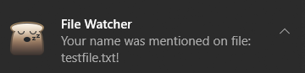

**User Interface**

The app will accept two parameters in the CLI:

* Name: The user’s name that will be used to check if exist on any given file
* Path: The directory path that the app will watch for any changes

Sample CLI

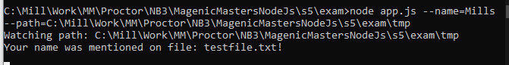

**Business Requirements**

* When the app starts, it will print the directory path to be monitored:
  + `Watching path: ${path}`
* The app will monitor any file changes on the specified folder path
  + If any text file were added or modified, the app will read the file and check if the specified name exists
  + If your name exists, the app will load a windows toast message:
    - “Your name was mentioned on file: [FileName]”
  + Also, the app will print a message in the console:
    - “Your name was mentioned on file: [FileName]”
* Any changes on the given path should be monitored including sub folders

Example: If the user specified to watch “c:\test” directory, it should watch also watch “c:\test\subfolder1” and “c:\test\subfolder1\subfolder2”

* Name search is non case-sensitive

**Technical Requirements**

* Use EventEmitter class to create events for file watcher
* When the matching name was found in the file, your application should emit an event called “nameFoundOnFile”
* Create a two event registration for this event
  + openToastNotification: This event registration will open a windows Toast message
  + printToConsole: This event registration will print the message on the console window
* Use **yargs** NPM package to intuitively handle user input
* You may use any NPM package to display windows toast message
  + I used **node-notifier** NPM package when I designed this exam
* Create a FileWatcher class that extends EventEmitter class. FileWatcher class will handle watching the folder path and just emit the “nameFoundOnFile”